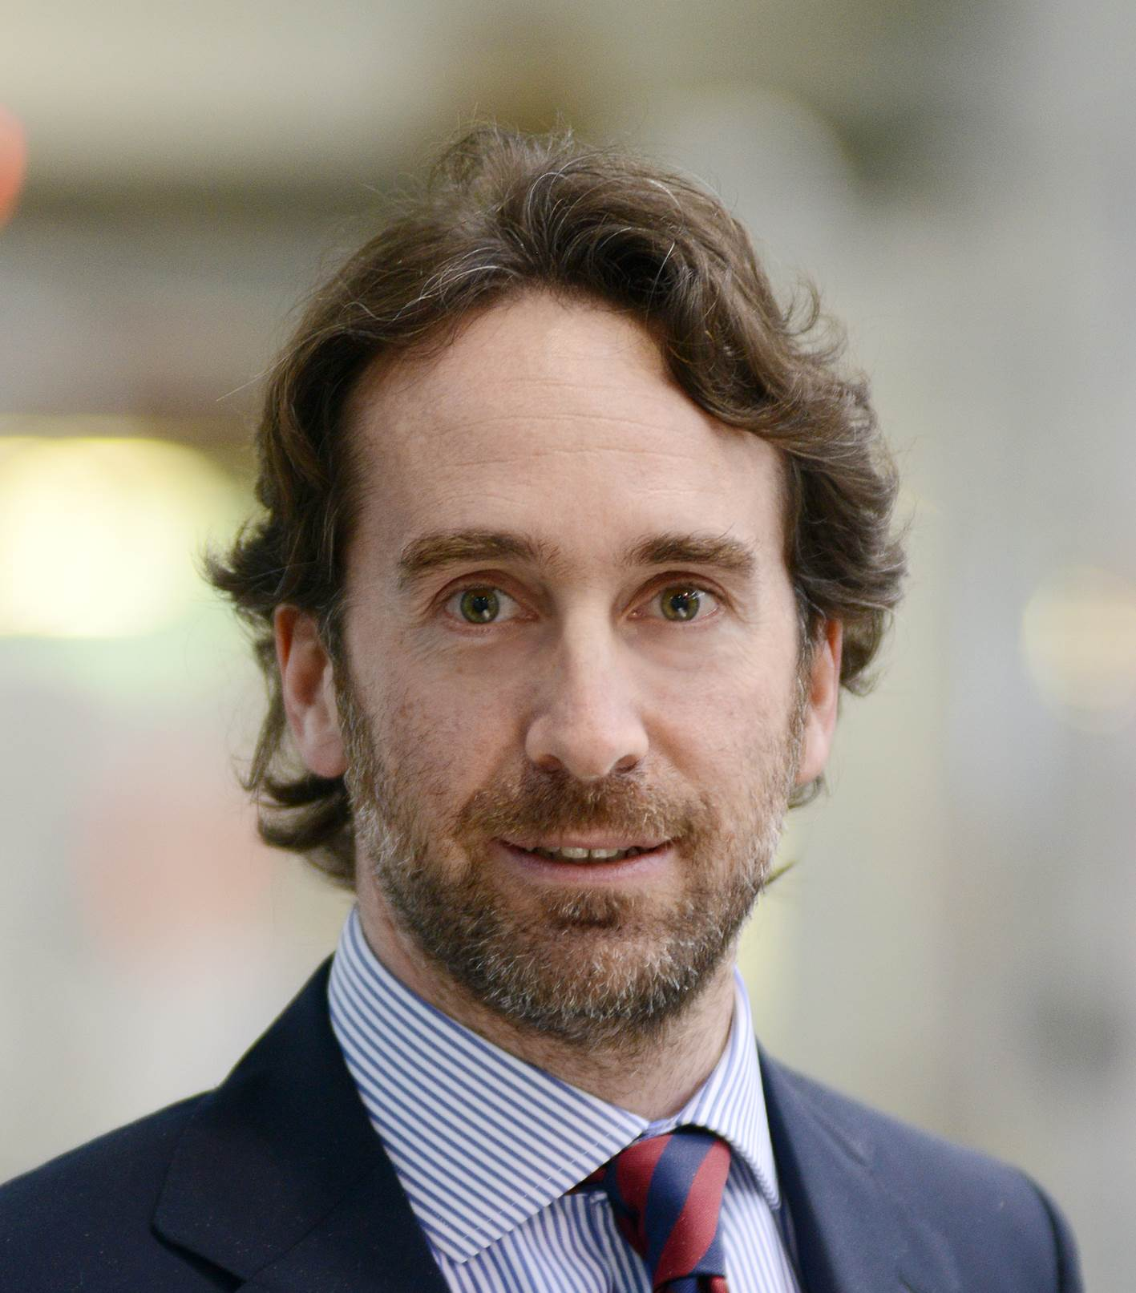ENNIO CHIATANTE

Ennio Chiatante is Global Business Development at Comau since 2019. In 1996 he began his career in Fiat Group (now FCA Group) as Project Manager. In 1998 he began to work at Comau, coordinating the product engineering business for Comau do Brasil SA in Betim. In 2000 he returned to Comau Italy as Project Manager within the Engineering Business Unit. Following this experience, from 2004 to 2007, he took on the role of Engineering Business Developmet Manager at Comau Shanghai Ltd. Returning to Italy again in 2007, Chiatante covered different and important roles at Comau, as Manager for the Engineering BU and for the Body Welding & Assembly BU. From 2017 to 2019 he was Head of Digital Transformation Projects. In 2019, he became part of Comau's Electrification BU as Global Business Development. He graduated in 1996 in Mechanical Engineering and Business at Birmingham University (UK).

BIOGRAPHY

Ennio Chiatante è Global Business Development di Comau dal 2019. Nel 1996 arriva in Fiat Group (l’attuale FCA Group) in qualità di Project Manager. Nel 1998 inizia a lavorare in Comau, coordinando l'attività di Product Engineering per Comau do Brasil SA, a Betim. Nel 2000 torna in Italia, collaborando come Project Manager presso la Business Unit Engineering di Comau. Dopo questa esperienza, dal 2004 al 2007, assume l’incarico di Engineering Business Developmet Manager presso Comau Shanghai Ltd. Di nuovo in Italia, dal 2007 al 2016, Chiatante ricopre diversi e importanti ruoli all’interno di Comau, come responsabile della BU Engineering e della BU Body Welding & Assembly. Dal 2017 al 2019 è Head of Digital Transformation Projects. Nel corso del 2019 entra a far parte della BU Electrification di Comau, come Global Business Development. Si è laureato nel 1996 in Mechanical Engineering and Business presso l'Università di Birmingham (Regno Unito).

***To interview ENNIO CHIATANTE please contact Giuseppe Costabile:*** [***press@comau.com***](mailto:press@comau.com)