Giuseppe Quaglia
Short CV

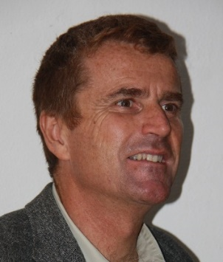
Giuseppe Quaglia, Master of Science’s Degree in Mechanical Engineering and PhD in Applied Mechanics, in 1994 entered the role of researcher, in applied mechanics, at the Department of Mechanics of the Politecnico di Torino, where he became Associate Professor in 2003 and Full Professor in 2018.
His main research topics are:
Energy saving and renewable energy; vehicle dynamic and systems; robotics, automation, actuators and mechanisms; device for disabled people and biomedical applications;. appropriate technologies and systems for sustainable human development.
The research has produced not only theoretical analyses, mathematical models and projects, but often led to the creation of innovative prototypes (wheelchairs, actuators and pneumatic systems, vehicle suspensions, mechanisms and wrists for robots, mobile robots, steer by wire systems), some of them are described in national and international patents.
He had the scientific responsibility of competitive National and International research projects, awarded through a peer-review process. He has also carried out and/or coordinated numerous research projects between Politecnico di Torino and private companies including COMAU, FIAT FERROVIARIA SpA, DAYCO, MERLO, CORCOS SpA , TEXA AT, RANCILIO, CF Gomma, SKF industrie S.p.A, TESEO, FREUDENBERG SEALING TECHNOLOGIES.
Prof. Quaglia had many Institutional offices and roles in Italian Universities and/or public and private institutions with scientific and/or technology transfer aims. He was member of the Academic Senate of the University “Politecnico di Torino”, he is member ASME, deputy chair of IFToMM Italy and chair of the World IFToMM Technical Committee on Sustainable Energy System, Member of SIRI council, (Associazione Italiana di Robotica e Automazione, Italian Association of Robotics and Automation).
Prof. G. Quaglia is a member of the Management Board of “Politecnico Interdipartmental Center for Service Robotics” (PIC4SeR), laboratory established by the Politecnico di Torino.

